**SpringBoot Adding Spring Security Login, Adding -** override loadUserByUsername

public class AccountService implements UserDetailsService

{

}

**Implemented Methods -** UserDetailsService

@Override

    public UserDetails loadUserByUsername(String username) throws UsernameNotFoundException {

        // TODO Auto-generated method stub

        throw new UnsupportedOperationException("Unimplemented method 'loadUserByUsername'");

    }

**AccountService.java Updated**

package org.studyeasy.SpringStarter.services;

import java.util.ArrayList;

import java.util.Optional;

import java.util.List;

import org.springframework.beans.factory.annotation.Autowired;

import org.springframework.security.core.GrantedAuthority;

import org.springframework.security.core.authority.SimpleGrantedAuthority;

import org.springframework.security.core.userdetails.User;

import org.springframework.security.core.userdetails.UserDetails;

import org.springframework.security.core.userdetails.UserDetailsService;

import org.springframework.security.core.userdetails.UsernameNotFoundException;

import org.springframework.security.crypto.password.PasswordEncoder;

import org.springframework.stereotype.Service;

import org.studyeasy.SpringStarter.models.Account;

import org.studyeasy.SpringStarter.repositories.AccountRepository;

@Service

public class AccountService implements UserDetailsService{

    @Autowired

    private AccountRepository accountRepository;

    @Autowired

    private PasswordEncoder passwordEncoder;

    public Account save(Account account){

        account.setPassword(passwordEncoder.encode(account.getPassword()));

        return accountRepository.save(account);

    }

@Override

    public UserDetails loadUserByUsername(String email) throws UsernameNotFoundException {

        Optional<Account> optionalAccount = accountRepository.findOneByEmailIgnoreCase(email);

        if(!optionalAccount.isPresent()){

            throw new UsernameNotFoundException("Account not found!..");

        }

        Account account = optionalAccount.get();

        return new User(account.getEmail(),account.getPassword(),null);

    }

}

**AccountRepository.java**

@Repository

public interface AccountRepository extends JpaRepository<Account, Long>{

    @Query("SELECT a FROM Account a WHERE LOWER(a.email) = LOWER(:email)")

    Optional<Account> findOneByEmailIgnoreCase(@Param("email") String email);

}

**Output – You get below output**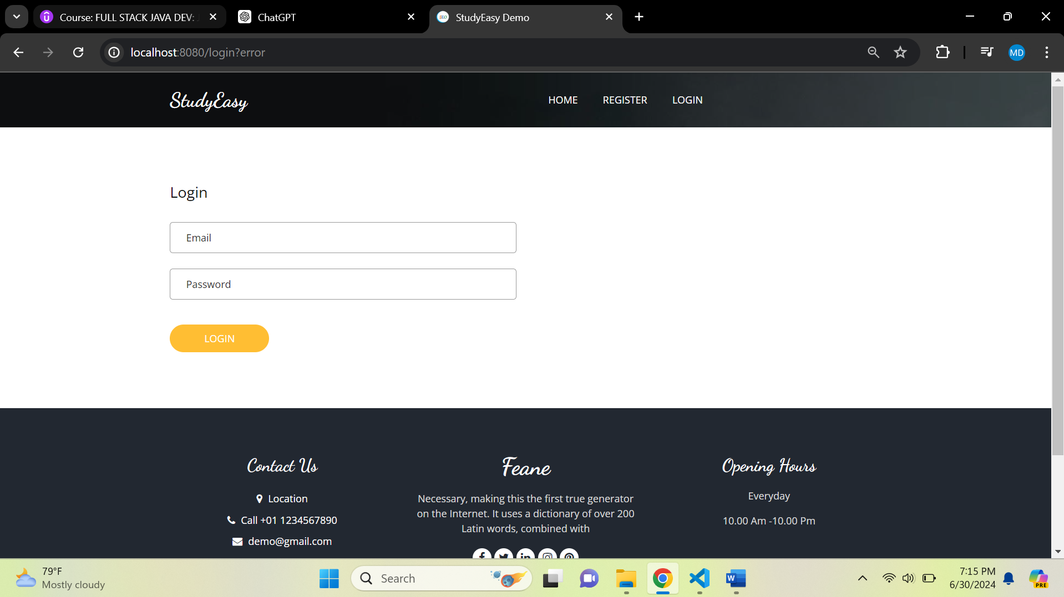



**Solution:-**

**Updated loadUserByUsername()**

@Override

    public UserDetails loadUserByUsername(String email) throws UsernameNotFoundException {

        Optional<Account> optionalAccount = accountRepository.findOneByEmailIgnoreCase(email);

        if(!optionalAccount.isPresent()){

            throw new UsernameNotFoundException("Account not found!..");

        }

        Account account = optionalAccount.get();

        List<GrantedAuthority> grantedAuthority = new ArrayList<>();

        grantedAuthority.add(new SimpleGrantedAuthority("Allow"));

        return new User(account.getEmail(),account.getPassword(),grantedAuthority);

    }

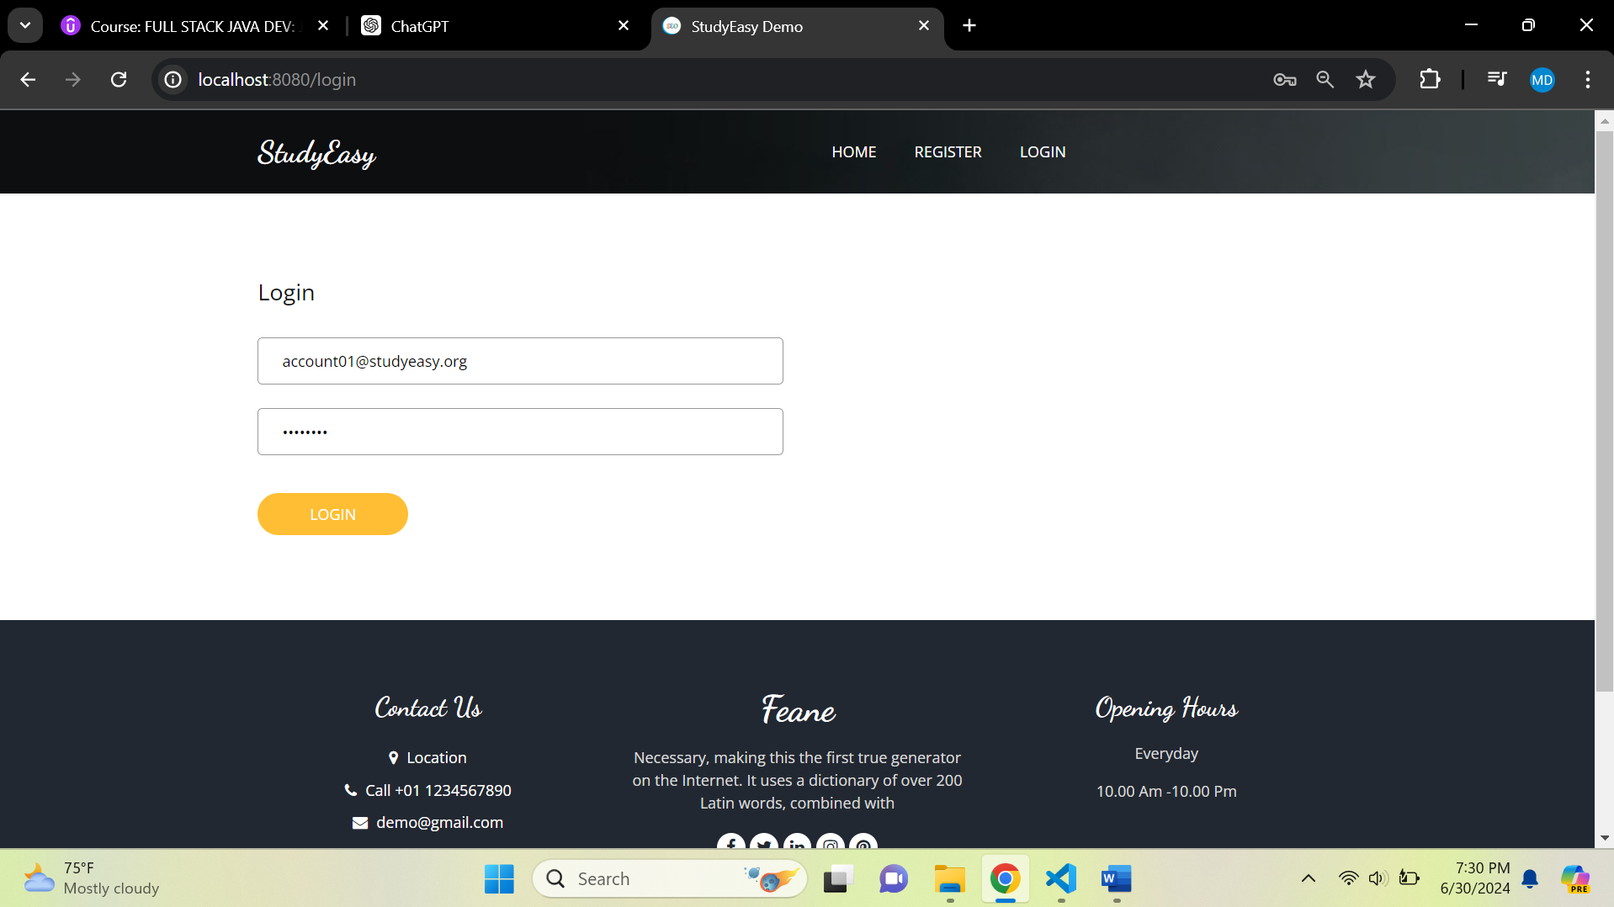



**After Logging in, the default page will be opened.**

